E-Invoice

Solution Design Document (SDD) v1.0

PropertyGuru.

Table of Contents­­­­

1. Objective 4

2. Solution Design 4

2.1 Solution Overview 4

2.2 Configuration for E-Invoice 4

2.2.1 Mapping Field Records 4

2.2.2 Custom fields for tracking E-invoice Status 6

2.2.3 E-Invoice Log 7

2.2.4 E-Invoice subtab 8

2.3 Transactions 8

2.3.1 Invoice Records (B2B transactions). 8

Project Information

|  |  |
| --- | --- |
| Customer Name | PropertyGuru. |
| Implementation Name | E-Invoice |
| Document Name and Version | Solution Document v1.0 |
| Document Owner | Devi Sri Prasad |
| Solution Architect | Sudheer Reddy |
| Project Manager | Ruthvik Khedkar |
| Document Revisions | 1.0­ |

# Objective

To implement the E-Invoice process in collaboration with Clear, to seamlessly continue with the below transactions:

1. Invoice
2. Credit Note
3. Bill
4. Bill Credit

# Solution Design

# Solution Overview

The below section covers various methods, rules, and configurations required to generate E-Invoice

# Configuration for E-Invoice

# Mapping Field Records

The below screen/table enables to map the mapping fields between Clear and NetSuite. Using the below screen all the fields required for E-Invoicing for all the transaction types Cash Sale, Invoice, Credit Note and Advance payment etc must be entered.

Custom Record Name: E-Invoice Config

|  |  |  |
| --- | --- | --- |
| Field Name | Field Id | Description |
| Transaction Type | custrecord_clear_fm_transaction_type | Type of transaction for mapping |
| NetSuite Field Id | custrecord_clear_fm_ns_field_id | NetSuite Transaction Field Internalid |
| NetSuite Field Name | custrecord_clear_fm_ns_field_name | NetSuite Transaction record field name |
| Clear Object | custrecord_clear_fm_clear_object | Clear API filed object |
| Clear Field Id | custrecord_clear_fm_clear_field_name | Clear API field ID |
| Clear Field Name | custrecord_clear_fm_clear_field_name | Clear API field Name |
| Clear Object Type | custrecord_clear_fm_object_type | Clear API field type |
| NetSuite Field Type | custrecord_clear_fm_field_type | Mapped Netsuite field type |
| NetSuite Base Record | custrecord_clear_fm_base_record | NetSuite base record to get value from for mapping to Clear API field (value of this field will be used when NetSuite Field Type is List/Record) |
| NetSuite Base Record Field | custrecord_clear_fm_base_field | Field to map from base record |

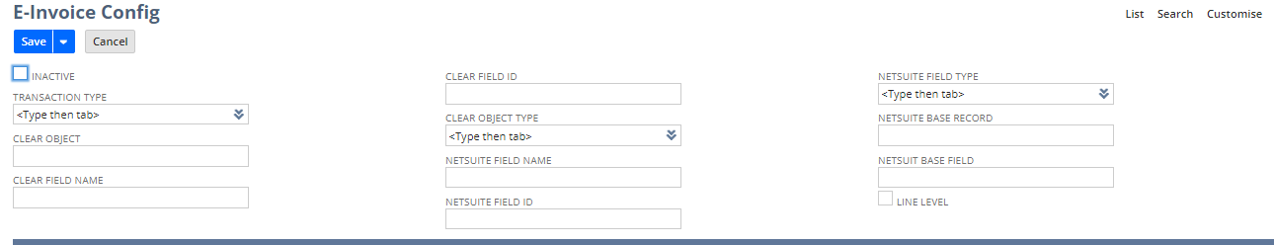

**E-Invoice Status :**

This field is to know the current status of E-Invoice.

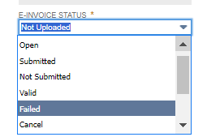 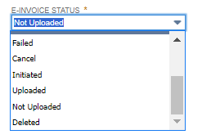

|  |  |
| --- | --- |
| List Of Value | Description |
| Open | When an Invoice /Credit Memo/Bill/Bill Credit is created in NetSuite  The default status is open |
| Submitted | If the Transaction record is Submitted to LHDN to generate an E-Invoice. |
| Not submitted | If any error occurs while Submitting transaction details to LHDN to generate an E-Invoice |
| Valid | If the E-Invoice is successfully generated |
| Failed | If the E-Invoice generation fails from LHDN |
| Cancel | If the E-Invoice is Cancelled(B2B) |
| Uploaded | If the B2C transaction is uploaded in the ClearTax portal |
| Not Uploaded | If the error occurs in uploading the B2C transaction to ClearTax portal |
| Deleted | If the B2C transaction is deleted in the ClearTax portal |
| Initiated | When the transaction details are sent to LHDN to submit |

# Custom fields for tracking E-invoice Status

Custom fields in transaction records to store Clear response details

|  |  |  |
| --- | --- | --- |
| **Field Name** | **Field Id** | **Description** |
| E-invoice Status | custbody_es_clear_status | Stores the E-invoice status |
| QR Code | custbody_es_clear_qr_code | Store the generated QR code |
| UUID | custbody_es_clear_uuid | Store the E-Invoice UUID |
| LongId | custbody_es_clear_longId | Store the E-Invoice LongId |
| DateTimeValidated | custbody_es_clear_date_time | Store the E-Invoice Validated Date and time |
| CancelDateTime | custbody_es_clear_cancel_date | E-Invoice Cancle Date and time |
| Cancel Reason | custbody_es_clear_cancel_reason | E-Invoice Cancel reason |
| ErrorDetails | custbody_es_clear_error_details | Stores the error message in case of error in generating E-Invoice |
| UniqueId | custbody_es_clear_unique _id | E-Invoice Unique ID |
| WarningDetails | custbody_es_clear_warning | Stores the Warning message in case of warnings in generating E-Invoice |
| PDF Status | custbody_clear_pdf_status | PDF generated status (Generated /Not Generated) |
| DeleteDate | Custbody_clear_delete_date | Document deleted date |
| E-Mail sent status | Custbody_clear_email_status | This status tracks wether the email of E-Invoice PDF is sent to customer or not when the E-Invoice is generated |

# E-Invoice Log

The E-Invoice log stores the status, request payload, response payload, transaction type, transaction number, and error message. Every activity/communication between NetSuite and Clear gets tracked. This record helps to find out the trail of particular E-Invoice

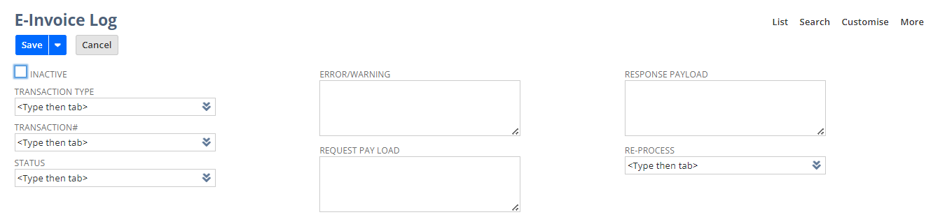

# E-Invoice subtab

In Transactions records new tab will be created “E-Invoice “ and keep track of all l the information related to E-Invoice along with the E-Invoice log attached to it.

# Transactions

# Generating E-invoice against B2B buyer (local) request e-invoice (PG, IPP, MPD only)

**Process Workflow to generate E-Invoice**

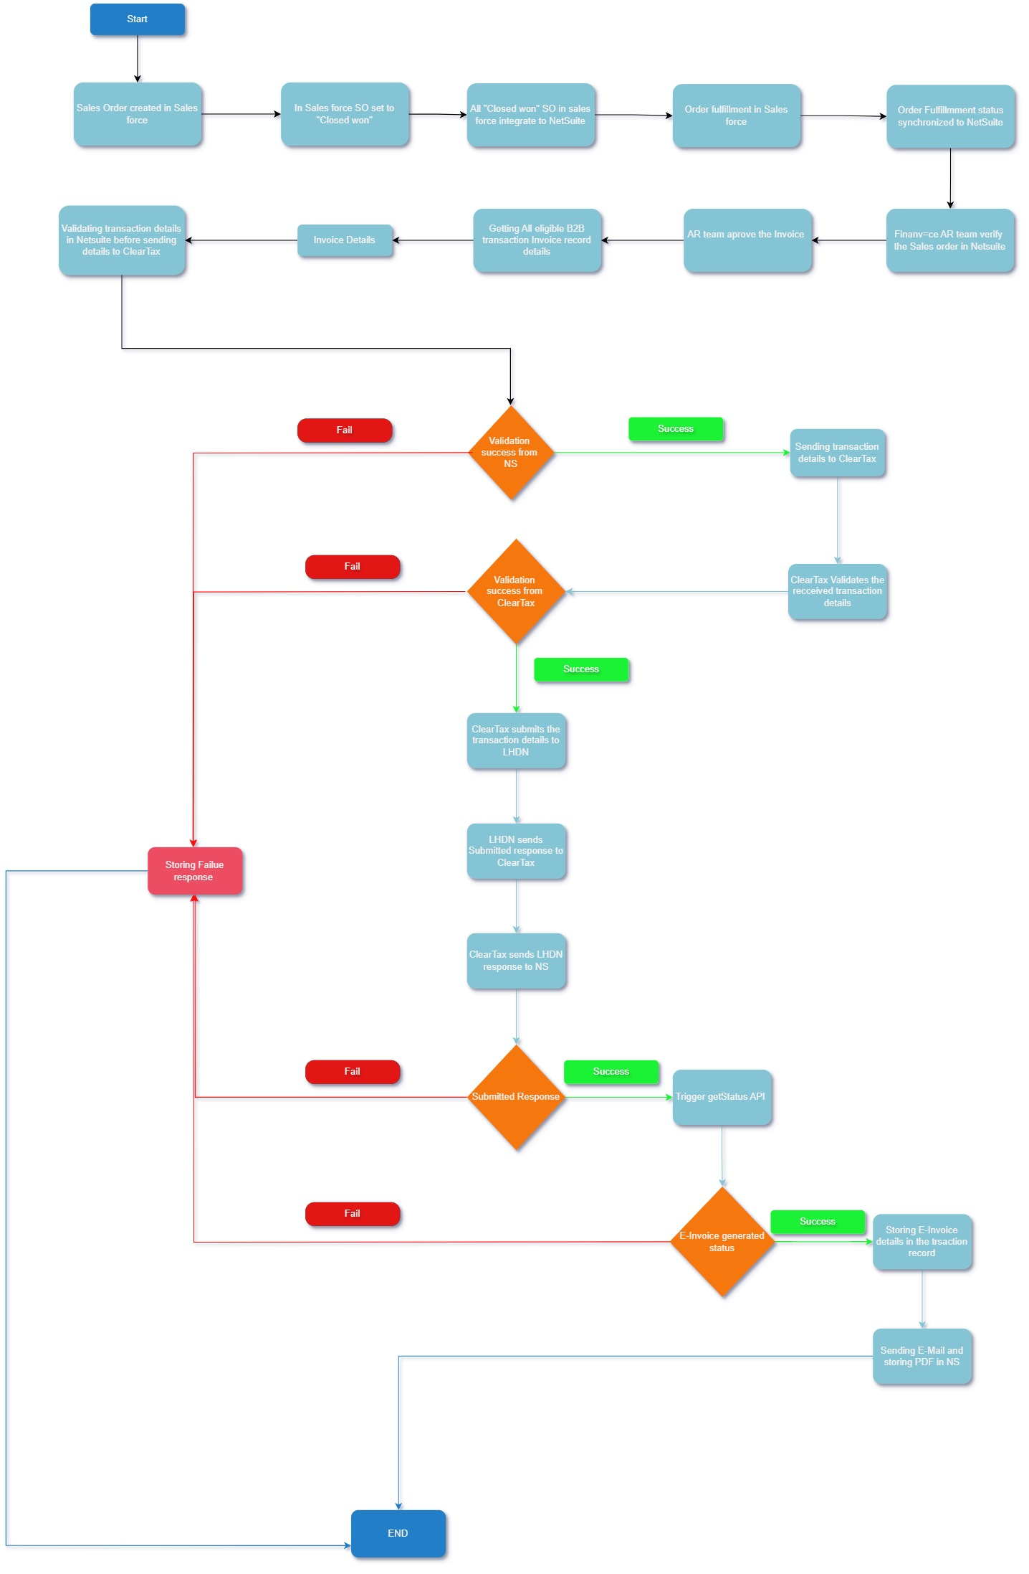

**Process steps:**

1. Getting all the eligible B2B Invoice record transaction details i.e., Invoice record status is approved, SF Txn Record Type is B2B and subsidiary is in Malaysia.
2. Validating each invoice record details before sending details to ClearTax to generate an E-invoice.
3. If validation fails, the reason is stored in the specific Invoice record and in the E-Invoice log records. Otherwise, the transaction details are sent to ClearTax via REST API, and at this stage, the E-Invoice status is set to 'Initiated'.
4. ClearTax validates the received transaction details. If validation fails, ClearTax sends the failure reason to NetSuite, which is stored in the specific Invoice record. Otherwise, ClearTax submits the transaction details to LHDN.
5. ClearTax sends the submission response from LHDN to NetSuite, where it is stored in the relevant transaction record. If the response indicates a failure, the reason for the failure is stored in the 'Error' field under the E-Invoice subtab. Otherwise, the UUID, Document ID, and Unique ID are populated in the appropriate fields and the E-invoice status is set to “Submitted” in the E-Invoice subtab.
6. In NetSuite, a scheduler runs every 15 minutes in the background to retrieve all Invoice records where the E-Invoice status is 'Submitted' and the UUID is not empty, in order to check the status of E-Invoice generation.
7. If the E-invoice generation is failed then the reason for failure is stored in the invoice record “Error” field and E-invoice status is set to “Failed” under the E-invoice subtab. Otherwise, the QR code, DateTimeValidated, and Long ID are populated in the appropriate fields by E-Invoice status is set to “Valid” in the E-Invoice subtab.

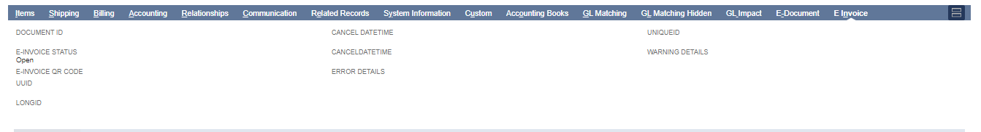

1. If the E-Invoice is generated, an email will be sent to the customer, and the E-Invoice PDF will be downloaded into a NetSuite folder. The PDF will then be linked to the specific Invoice record, and the E-mail sent status and PDF status fields will be updated to 'Success'.

Note: If any errors occurs in sending Email to customer or E-invoice PDF is not downloaded then the error response will store in the

1. A button with labelled “Download E-invoice” will be provided to download E-Invoice PDF for the particular Invoice record.